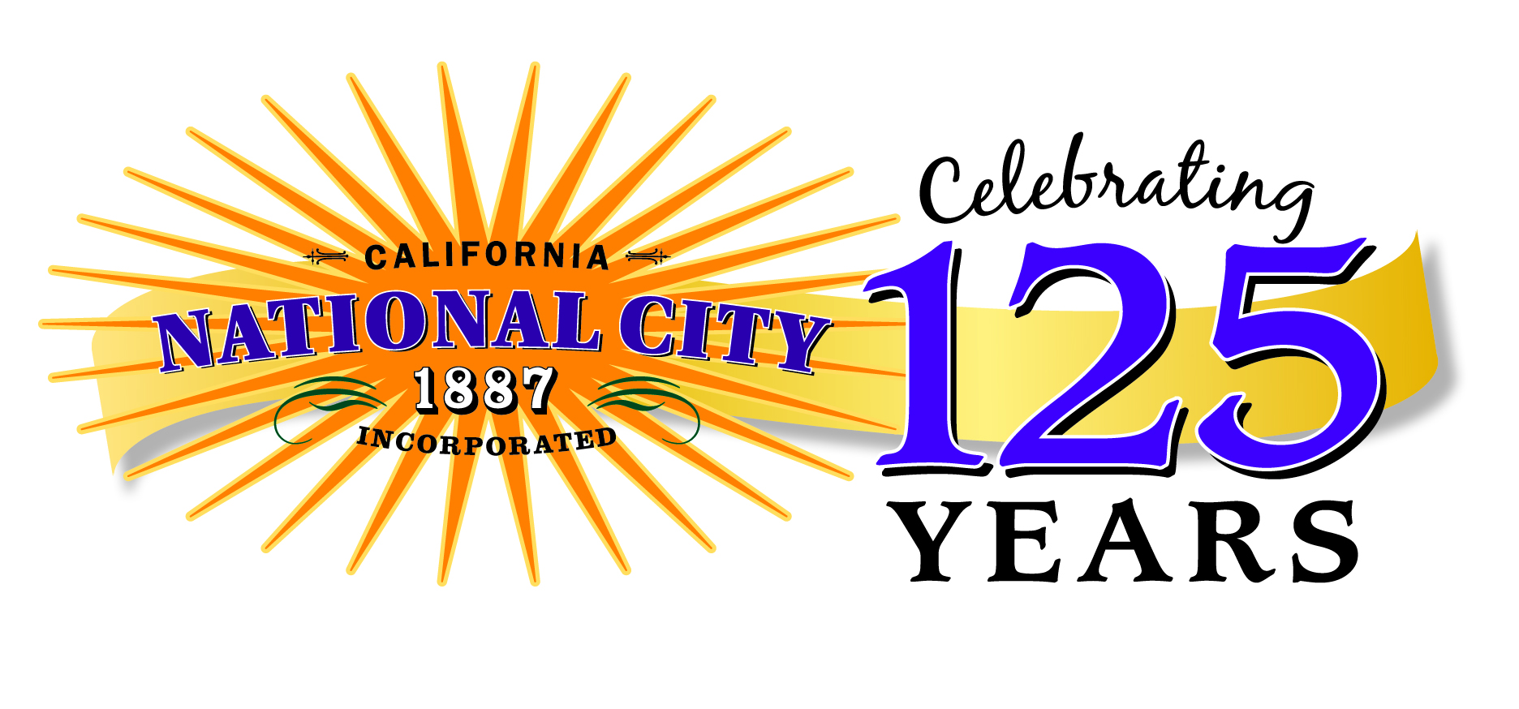

Public Art Committee

Minutes of the Special Meeting of May 21, 2013

ROLL CALL – Chairperson St. Clair called the meeting to order at 3:10 pm.

Commissioners: City Staff:
Carolyn St. Clair Jessica Cissel, Community Services
Manual Cavada Claudia Silva, City Attorney’s Office
Claudia Torres
William Virchis

MINUTES OF PREVIOUS MEETINGS
The committee approved the minutes for the meeting of April 23, 2013.

NON-AGENDA PUBLIC COMMENT
N/A

ACTION ITEMS
No action was taken.

NON-ACTION ITEMS
The Public Art Committee discussed project planning for the year ahead. They will spilt into two subcommittees and each subcommittee will work on two of the four project ideas for the upcoming year. They will meet with community groups (seniors, schools, teens, etc.) to see what art opportunities exist in National City.
Subcommittee 1: Carolyn St. Clair and Claudia Torres
Projects: Senior and youth art installations (contact Metro water district); other project
Subcommittee 2: William Virchis and Manual Cavada
Projects: Senior art mercardo (partner with senior yard sale and ceramics instructor) and possible concert; Mariachi fest (work with chamber).

Subcommittees will report back on their progress and planning schedule at the July meeting.

COMMISSIONER COMMENTS

ADJOURNMENT
The next special PAC meeting is scheduled for Tuesday, July 23, 2013 at 3:00 pm.

