AGENDA FOR REGULAR MEETING

PARKS, RECREATION & SENIOR CITIZENS ADVISORY COMMITTEE (PRSCAC)

THURSDAY, JANUARY 19, 2023 at 4:00 PM

**National City Civic Center**

**1243 National City Blvd, Large Conference Room, 2nd Floor National City, CA 91950**

Open to the Public

1. Call to Order
2. Pledge of Allegiance to the Flag
3. Roll Call and/or Introductions

Board: Florfina Arce, Liliana Armenta, Joseph Crawford, Reuben Felizardo, Nora McMain, Jennelyn Luna and Ignacio Navarro Jr.

City Staff and Guests:

1. Non-Agenda Public Comment:
2. Approval of Minutes: August 18, 2022
3. Presentations

* None

1. Action Items

* None

1. Non-Action Items
   * Camacho Reopening January 23, 2023.
2. Staff Reports and Comments
3. Board Member Comments
4. Adjournment to meeting of: February 16, 2023

Upon request, this agenda will be made available in an appropriate alternative format to persons with a disability. Contact the Community Services Department Office at (619) 336-4290 to request any disability-related modification or accommodation, including any auxiliary aids or services, that may be required by a person with a disability who requires such a modification or accommodation in order to participate in the public meeting***.***

# Unapproved Minutes

**Parks, Recreation, and Senior Citizens Advisory Committee Meeting**

**Regular Meeting Held on August 18, 2022**

The Regular Meeting of the Parks, Recreation and Senior Citizens Advisory Committee was called to order by Chairperson Nora McMains at 4:13pm.

# Roll Call:

Members Present: Joseph Crawford, Nora McMains, Reuben Felizardo, Liliana Armenta

and Florfina Arce

Members Absent: Ignacio Navarro Jr.

Staff Present: Juanita Castaneda and Maria Wright

Guests Present: Lorena Rojas, Miss National City 2022-2023

**Approval of Minutes:**  May 19, 2022 meeting minutes approved unanimously by a motion from Nora McMains and seconded by Florfina Arce.

**Presentations:**

* Introduction of the Miss National City 2022 Court – Juanita Castaneda

**Action Items:**

* None

# Non-actions Items:

* + Kimball Highland Master Plan Update
  + Upcoming Events

# Staff Reports and City Staff Comments:

* Maria Wright, Juanita Castaneda, and Elyana Delgado submitted reports for April 2022.

# Board Member Comments:

* Committee members requested information on Kimball Highlands plan and the specifics. How many residents and any other information.
* Reuben Felizardo asked the following questions:

1. Is a maintenance schedule for the waterway at Paradise Creek?
2. The El Toyon all-purpose field has only about 40% of the lights working and could become a liability /safety issue. Asked if the light bulbs could be changed.

* Florfina Arce asked the following:

1. Is there supposed to be private security scheduled in the Kimball Towers area?
2. Are the security cameras anywhere in the Kimball Towers area?

* Nora McMains asked the following:

1. At Las Palmas Park, is there a law that says owners have to pick up their dog’s poop?
2. Has called the Parks Division and would like a call back regarding the dry brush and homeless camp in the canyon at Las Palmas Park.
3. Would like the reasoning behind the decision to make boards and commission meetings virtual until the end of the year.

**Adjournment of meeting**: Motion by Joseph Crawford to adjourn meeting until September 15, 2022 and second by Reuben Felizardo at 5:08pm.

# STAFF REPORTS for November & December 2022

# Attachment to PRSCAC Agenda for January 19, 2023 meeting

**Kimball Senior Center**

* The Feeling Fit senior exercise class attendance for October 2022 was 131.

**Camacho Center**

* Camacho Center remains closed.

**El Toyon**

* El Toyon Recreation Center is currently hosting Ballet Folklorico winter program. Classes take place Monday through Thursday for all ages. Currently there are 98 participants registered for the winter season. Season dates ran from November 21st to February 19th.

# Special Events

# We are excited to once again report on our winter signature event - A Kimball Holiday! Over 3,000 participants joined the fun on Saturday, December 10th 2022, from 2:00 pm to 9:00 pm. Event goers enjoyed multiple free activities to include a Ferris wheel, sledding down the snow hill, dancing on the LED dance floor with music provided by a Live DJ, pictures with Santa & Mrs. Claus, and children received books at the Who-Ville with The Grinch.

**Las Palmas Pool**

* None

**Nutrition Center- November 2022 December 2022**

Congregate Senior

Dine In Meals: 2,872 3,023

Home Delivered Meals: 1,619 1,618

Non-Senior

Dine In Meals: 258 183

**Public Works- Parks Division**

Work completed in November and December 2022: spray weeds in all parks, work ballfields, irrigation repairs, remove homeless camps, removed nine dead Date Palms, weed abatement at various locations and worked on getting parks ready for furlough. In addition, 62 trees trimmed, 6 trees removed, and 10 trees stumped.

# Manuel Portillo Casa de Salud Youth Center

* The ESPORTS Afterschool program continues for youth 10-17 but we recently opened registration for those ages 8-10 as well. This program provides the youth with an opportunity to participate in competitive gaming, while socializing in person as well as learning how to use a 3D printer, Circuit machine and put together a computer from scrap parts. The youth that signed up are really happy to have this free program.
  + Youth had their December ESPORTS tournament on December 3rd, it was a lot of fun for the youth as well as their family members who supported them and cheered them on while they competed.
  + The ESPORTS program has been hosting an hour of a physical activity which the youth have really enjoyed and started to take walking field trips to Kimball park once a week when weather permits.
* Morning Socials continue and they are held twice a week at Casa de Salud. There are currently 58 seniors registered for this program.
  + Morning Socials invite seniors to participate in two hours of activities and socializing.
  + Activities include arts & crafts, dancing, karaoke, celebrations, coffee and snacks.

**Age Friendly Communities Grant events:**

* Senior Socials are a combination of Senior Saturday events at Kimball Park and Senior Dances.
  + On Friday, December 16th we hosted the first dance in a series of four. It was named the Winter Senior Dance and had over 100 seniors in attendance.
    - Seniors were entered into an opportunity drawing upon arrival. We provided appetizers, coffee, aguas frescas, a live DJ performance and a photo booth with unlimited photo prints for the participants.

Winter Senior Dance

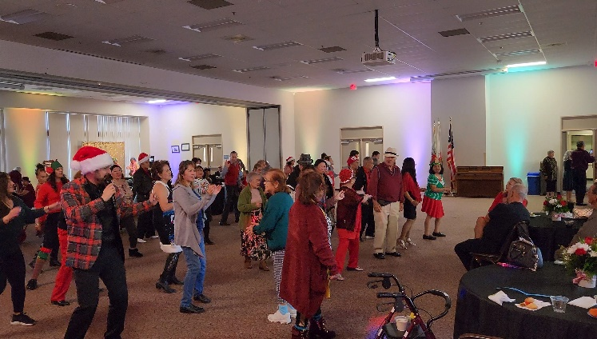

ESPORTS Winter Tournament

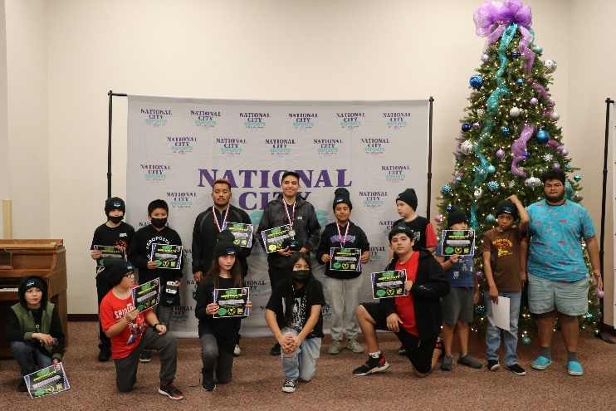

# STAFF REPORTS for October 2022

# Attachment to PRSCAC Agenda for November 17, 2022 meeting

**Kimball Senior Center**

* The Feeling Fit senior exercise class attendance for October 2022 was 131.

**Camacho Center**

* Camacho Center remains closed.

**Las Palmas Pool**

* The pool construction continues to progress and is officially done with the demolition portion of the project.  The project is currently on track for an April reopening date.

**Nutrition Center- October 2022**

* Congregate Senior Dine In Meals: 3,582
* Home Delivered Meals: 1,619
* Non-Senior Dine In Meals: 248

**Public Works- Parks Division**

Work completed in October 2022: spray weeds in all parks, work ballfields, irrigation repairs, remove homeless camps and weed abatement at various locations. In addition, XX trees trimmed, XX trees removed, and XX trees stumped.

# Manuel Portillo Casa de Salud Youth Center

* Youth Club is an afterschool program for youth ages 8 to 12 where the youth get to explore different hobbies.
* Our ESPORTS Afterschool program continues for youth ages of 10-17. This program provides the youth with an opportunity to participate in competitive gaming, while socializing in person as well as learning how to use a 3D printer, Cricut machine and put together a computer from scrap parts. The youth that signed up are really happy to have this free program.
  + Youth had their Fall ESPORTS tournament on October 15th, it was a lot of fun for the youth as well as their family members who supported them and cheered them on while they competed.
* Both youth programs have been collaborating and having an hour of a physical activity which the youth have really enjoyed and started to take walking field trips to Kimball park once a week.
* Morning Socials continue and they are held twice a week at Casa de Salud. There are currently 47 seniors registered for this program.
  + Morning Socials invite seniors to participate in two hours of activities and socializing.
  + Activities include arts & crafts, dancing, karaoke, celebrations, coffee and snacks.

Fall Tournament

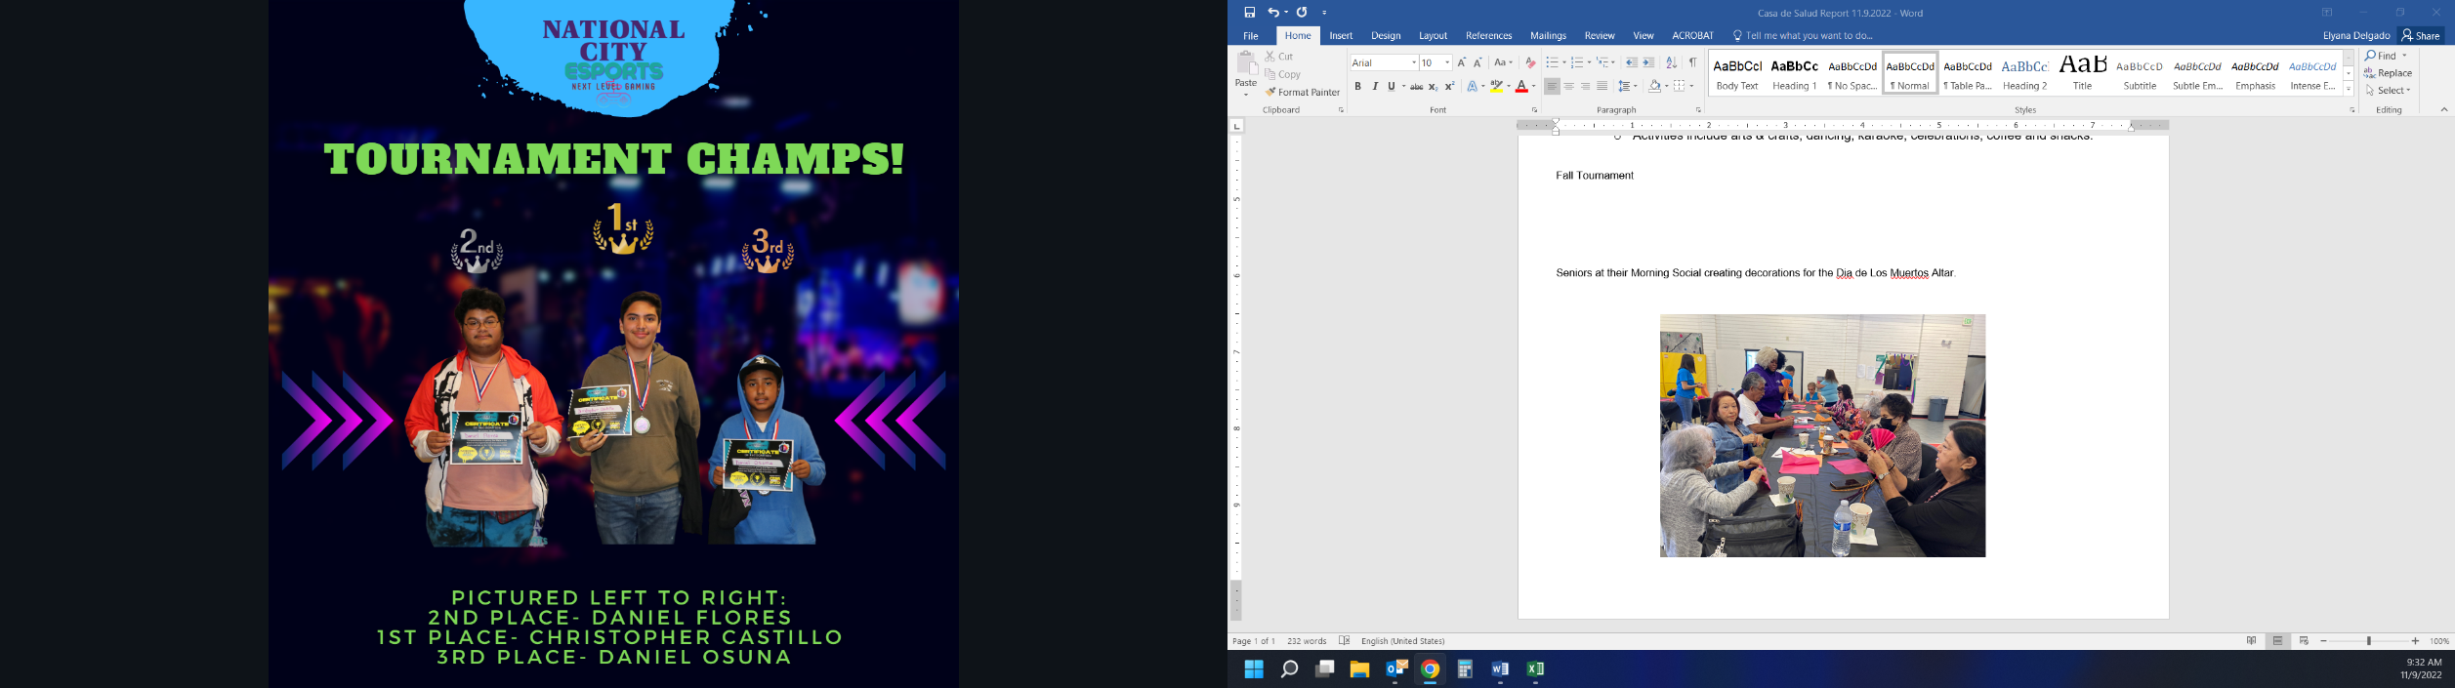

Seniors at their Morning Social creating decorations for the Día de Los Muertos Altar.

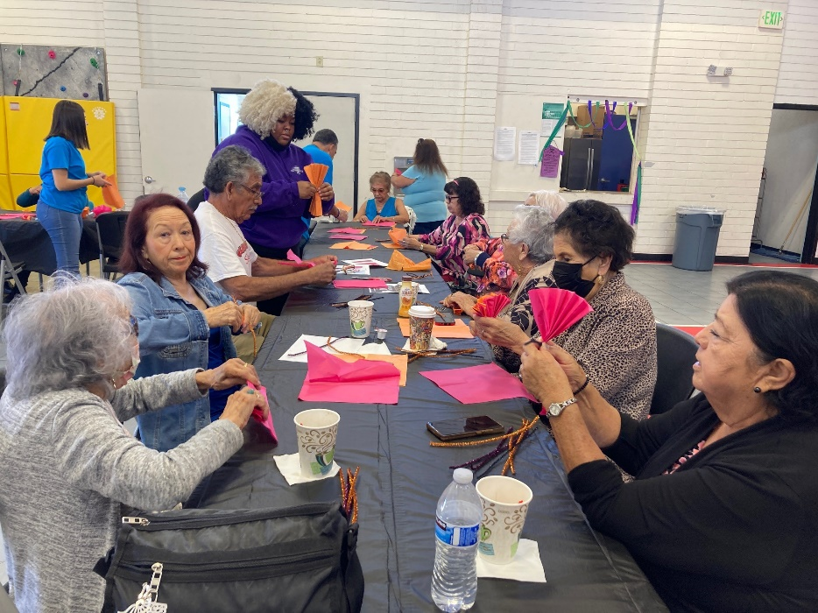

# STAFF REPORTS for September 2022

# Attachment to PRSCAC Agenda for October 20, 2022 meeting

**Kimball Senior Center**

* The Feeling Fit senior exercise class changed their class time from 9:00am -10am to 12:30-1:30pm. This started in the month of September. The class attendance for September 2022 was 116.

**Camacho Center**

* Camacho Center remains closed.

**El Toyon**

* El Toyon Recreation Center started fall season for the Ballet Folklorico program. The instructor added a whole new class to Monday and Wednesday to be able to help with the demand of the classes. The season is now at 100 participants registered. Season dates ran from August 23rd to November 20th.

**Las Palmas Pool**

* Construction finally started at Las Palmas in September.  The start of the process has been all demolition, which includes removing all of the pool plaster and majority of the pool deck.  The slide and diving boards were also removed, as the area the slide was occupying will eventually become a splash pad area for kids in the next phase of park upgrades.

**Nutrition Center- September 2022**

* Congregate Senior Dine In Meals: 3,825
* Home Delivered Meals: 1,790
* Non-Senior Dine In Meals: 235

**Public Works- Parks Division**

Work completed in September 2022: spray weeds in all parks, work ballfields, irrigation repairs, remove homeless camps and weed abatement at various locations. In addition, 52 trees trimmed, 6 trees removed, and 10 trees stumped.

# Manuel Portillo Casa de Salud Youth Center

* Youth Club is an afterschool program for youth ages 8 to 12 where the youth get to explore different hobbies.
* Our ESPORTS Afterschool program continues for youth ages of 10-17. This program provides the youth with an opportunity to participate in competitive gaming, while socializing in person as well as learning how to use a 3D printer, Cricut machine and put together a computer from scrap parts. The youth that signed up are really happy to have this free program.
  + Youth have been having weekly tournaments in preparation for Fall ESPORTS tournament where they will showcase their skills to their friends and families.
* Both youth programs have been collaborating and having an hour of a physical activity which the youth have really enjoyed.
* This month our staff kicked off Morning Socials which are held twice a week at Casa de Salud. There are currently 35 seniors registered for this program.
  + Morning Socials invite seniors to participate in two hours of activities and socializing.
  + Activities include arts & crafts, dancing, celebrations, coffee and snacks.
  + The pictures below are from their Mexican Fiesta where the De Colores Rondalla (a musical performing group composed of seniors) performed.

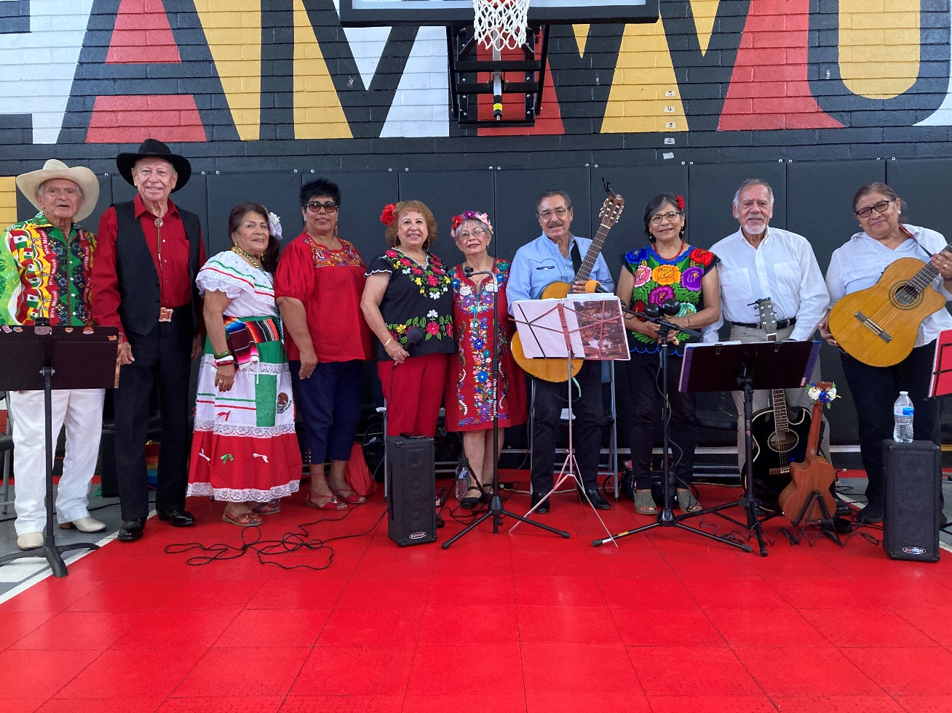

# IMG_0786

# STAFF REPORTS for August 2022

# Attachment to PRSCAC Agenda for September 15, 2022 meeting

**Kimball Senior Center**

* The Feeling Fit senior exercise class attendance for August was 118.

**Camacho Center**

* Camacho Center remains closed.

**El Toyon**

* El Toyon Recreation Center started fall season for the Ballet Folklorico program. The season started with 74 participants registered. Season dates ran from August 23rd to November 20th.

# Special Events

# Library and Community Services Department hosted National City Movie Nights on Saturday, August 6th. Residents of National City were invited to Kimball Park to bring lawn chairs, blankets and snacks to watch Uncharted at sunset.

# On Saturday, August 13th we hosted our second Senior Saturday in the second phase of this series there were around 80 community members in attendance.

**Las Palmas Pool**

* The Las Palmas pool is still closed for renovations.  The contract for the renovations was awarded at the August 16th council meeting, and the pool has now been drained.
* Construction should begin within the next week or so, getting more information later today in an update meeting.

**Nutrition Center- August 2022**

* Congregate Senior Dine In Meals: 3,473
* Home Delivered Meals: 1,717
* Non-Senior Dine In Meals: 231

**Public Works- Parks Division**

Work completed in August 2022: spray weeds in all parks, work ballfields, irrigation repairs, remove homeless camps and weed abatement at various locations. In addition, 55 trees trimmed, 5 trees removed, and 15 trees stumped.

# Manuel Portillo Casa de Salud Youth Center

* Youth Club is an afterschool program for youth ages 8 to 12 where the youth get to explore different hobbies.
* Our ESPORTS Afterschool program continues for youth ages of 10-17. This program provides the youth with an opportunity to participate in competitive gaming, while socializing in person as well as learning how to use a 3D printer, Cricut machine and put together a computer from scrap parts. The youth that signed up are really happy to have this free program.
* Youth have been having weekly tournaments in preparation for fall ESPORTS tournament where they will showcase their skills to their friends and families.