January 14, 2019

**SUBJECT**: **Intake Guidelines for Arresting Agencies**

________________________________________________________________

As part of the continuing efforts to improve business processes, and to enhance inmate access to medical and mental health services, the San Diego Sheriff’s Department has identified areas in which communication between agencies can be improved. The following guidelines will assist you in determining if an arrestee should be taken to a local emergency hospital and/or the San Diego County Psychiatric Unit instead of going directly to a Sheriff’s Department intake facility for booking.

Beginning in 2018, the Sheriff’s Department implemented a revised medical intake screening process, which included new questions that not only gather additional health information on arrestees, but also engages the arresting or transporting officer in providing medical staff further insight on observations or actions that occurred during or prior to arrest. This information is vital to improve access to medical care, provide better outcomes, and limit exposure to costly litigation. It is imperative for arresting or transporting officers to communicate with medical intake staff any concerning behavior, use of force incidents, or pertinent statements made by the arrestees so that most accurate assessment can occur.

Although there are exceptions to the guidelines, determining an arrestee’s medical and mental health stability are evaluated on a case-by-case basis. Due to the revisions of the medical intake screening process, the San Diego Sheriff’s Department facilities will have a better understanding of the needs of the arrestee.

INTAKE GUIDELINES FOR LAW ENFORCEMENT AGENCIES:

**Medical or psychiatric conditions which may require emergency medical or psychiatric evaluation and / or treatment prior to booking into jail:**

*Medical clearance into the jails is incumbent upon an individual's presenting conditions and a nurse's assessment. How an individual handles pain and is able to communicate what they are experiencing varies greatly. There are no hard and fast rules as we are dealing with health issues. With that said, here are some general guidelines that may assist in whether to take an individual to receive emergency services prior to transporting to jail.*

**Medical considerations which may require a medical evaluation or treatment at an Emergency Department prior to being accepted at a jail for booking:**

* Trauma (Motor vehicle accident, falls, and/or altercation with head, chest and abdominal injury).
* Obvious signs of deformity on an extremity to suggest a possible fracture.
* Signs of bleeding- vomiting blood, bleeding from one or both ears, severe nosebleeds.
* Loss of consciousness.
* Extremely drowsy/sleepy and difficult to arouse.
* Actively having a seizure or post seizure.
* Difficulty breathing.
* An individual verbalizing that they have swallowed a baggie of drugs.
* Suicide attempts – Ligature marks, deep lacerations, overdose.

**Mental Health considerations which may require a medical and possible psychiatric evaluation at an Emergency Department and/or at the San Diego County Psychiatric Hospital prior to being accepted at a jail for booking:**

* Exhibiting signs of Excited Delirium: (This could include profuse sweating, increased temperature, extreme agitation, uncooperative behavior).
* Disorganized in thought (to time, date, year, name, location, etc.).
* Nonsensical communication.
* Altered mental status, disoriented.
* Confused.

**Additional considerations:**

* The clearance by a paramedic does not take the place of an emergency room evaluation.
* An individual must be able to walk or move on their own in order to be medically cleared.
* An individual requiring restraints (either the WRAP or Cord Cuff) to remain applied due to their status (exhibiting signs of Excited Delirium such as agitated, violent, hostile, profuse sweating, etc.) should be taken to the Emergency Department.

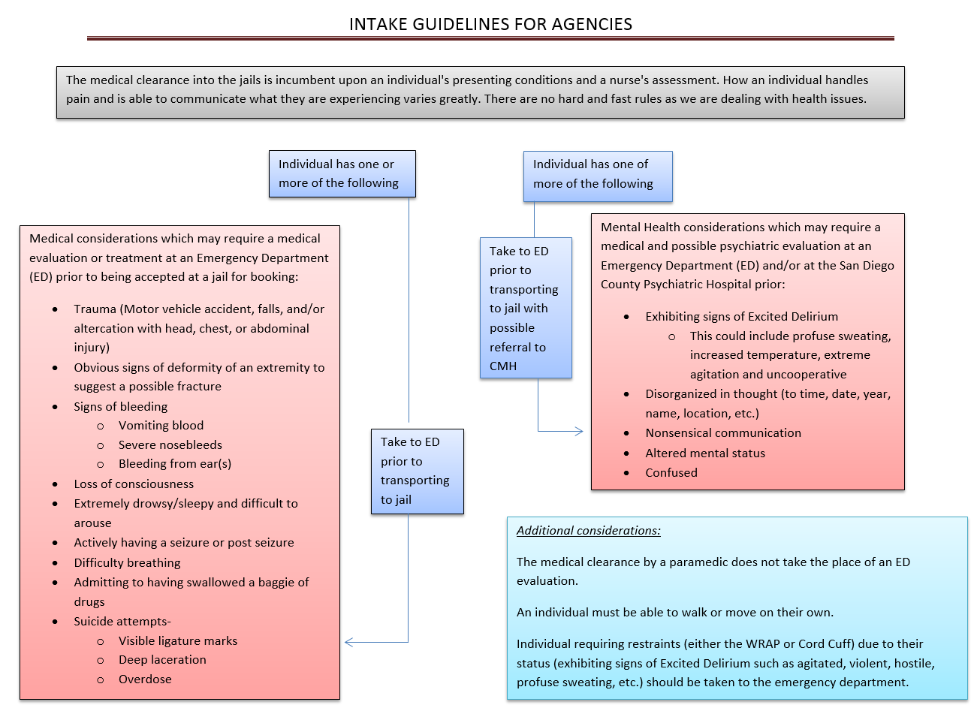

Please contact Lieutenant Chris Sullivan at 619-336-4223 with any questions.